Editorial Contest Winner | ‘The Shameful Saga of Guantánamo Bay’
By
THE LEARNING NETWORK

MAY 20, 2016 6:00 AM May 20, 2016 6:00 am 1
Photo
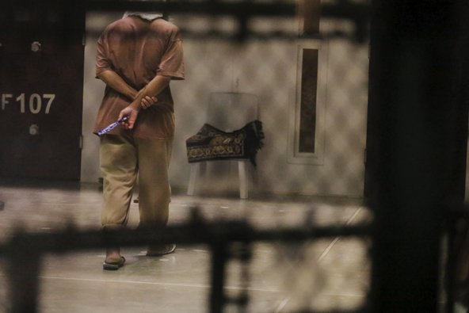
A Guantánamo detainee in March. Related ArticleCredit Lucas Jackson/Reuters
We are honoring each of the Top 10 winners of our Third Annual Student Editorial Contest by publishing an essay a day. You can find them all here.
Below, an essay by Quinna H, age 14.

The Shameful Saga of Guantánamo Bay
In 2008, then presidential hopeful Barack Obama promised to end what he called the “sad chapter of American history” that is Guantánamo Bay. Today, as his tenure ticks down to a close, the uncertain fate of 91* men remains at the hands of an idle Congress. Guantánamo, supposedly a necessary security containment of the world’s most dangerous enemies, has become a surreptitious cycle of extreme torture outside the law for questionably selected prisoners — including a 13-year-old boy and 89-year-old man. It must be closed.
The United States must close Guantánamo Bay and transfer the remaining inmates to maximum-security federal prisons. Of the remaining, 34 men have already been cleared for release by the government. Furthermore, the U.S. has admitted to lacking evidence to prosecute 28 prisoners but claims they are “too dangerous to release.” This is unacceptable as a country that continually reprimands other countries for imprisonment without due process of law. It currently costs $120 million annually to maintain these cleared prisoners in Guantánamo, but it would cost $1.2 million annually to maintain 34 prisoners found guilty in a federal prison. But Guantánamo’s faults lie far beyond fiscal matters. Over 200 F.B.I. agents have reported inhumane torture.
Serious concerns about torture have risen from inside the C.I.A. itself. When C.I.A. interrogators questioned the legality of the brutal torture, senior C.I.A. personnel insisted they move forward because it had been vetted by the highest levels of the organization. One interrogator, Sergeant Erik Saar, confessed on “60 Minutes” that C.I.A. personnel were told that Guantánamo prisoners aren’t prisoners of war and therefore not covered by the Geneva Convention. In other words: there were no limits to torture. Many prisoners were conscripts forced against their will to fight for the Taliban, others were individuals picked up by the Northern Alliance, whom Saar confesses, “[the C.I.A. had] no idea why they were there […] what their connections were to terrorism.”
The C.I.A. was created as an auxiliary to the federal government and thus bears an obligation to confide the whole truth. Yet, C.I.A. Director Michael Hayden actively encouraged employees to report false statistics to the Senate to downplay the frequency and extent of torture. Hayden testified that brutal interrogation was used only as a last resort to extract actionable intelligence from uncooperative suspect Abu Zubaydah. C.I.A. internal records showed otherwise; Zubaydah divulged information about Qaeda activities, leadership and training. Hoping for information about future attacks, the C.I.A. subjected him to 47 days in isolation and enhanced waterboarding. According to the report, the waterboarding was more akin to “near drowning.”
Guantánamo is a disgrace to the United States: the land of the free, not the land of limitless torture.
Works Cited
“7 Key Points From the C.I.A. Torture Report.” The New York Times. 09 Dec. 2014.
Guantánamo by the Numbers. A.C.L.U.
Leung, Rebecca. “Note: As of May 16, 2016, there were 80 men still being held at Guantánamo.

