How to Read to Understand: Close Reading

Instructions: Close read the article using the following steps. This requires you to read the article at least twice and annotate the article (add notes that explain or comment on the article). Then answer the questions.

Step 1. Read the article paragraph-by-paragraph. (Objective – Does Everything Make Sense or Are you Confused?)

☐ Put a question mark next to any confusing ideas or sentences that you don’t understand.
☐ Circle any words you don’t understand.
☐ Next to each circled word, write down what you think the word might mean based on how the word is used in the sentence.

Step 2. Re-read the article paragraph-by-paragraph. (Objective – What is it Mainly or Mostly Talking About?)

☐ In each paragraph, underline 3-4 key words.
These should be words that give important information about the topic of the paragraph and article.
☐ After you finish each paragraph, write a phrase or two next to the paragraph to remind yourself what the paragraph is mainly about.

Trump aide offers resignation in Melania Trump plagiarism incident
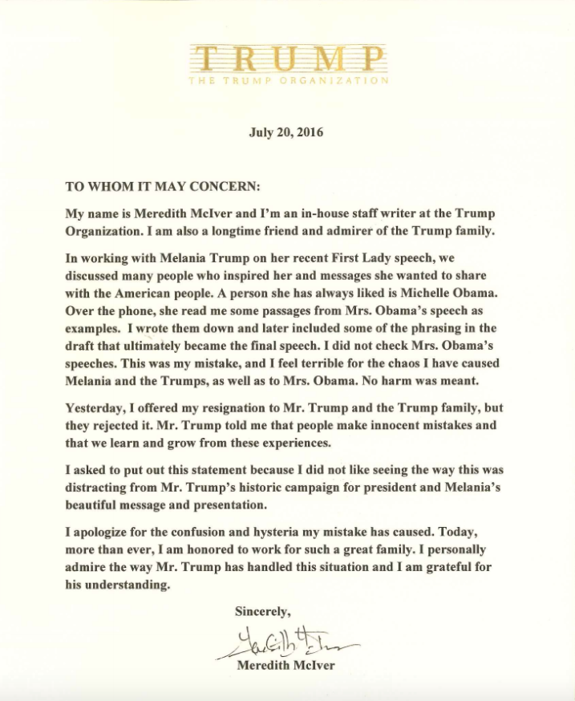
cnn.com/2016/07/20/politics/trump-aide-offers-resignation-in-melania-trump-plagiarism-incident/index.html
7/20/2016
"She made a mistake ... we all make mistakes," Donald Trump told ABC News later Wednesday.
McIver's statement comes more than 36 hours after reporters uncovered striking similarities between the two speeches --during which time the controversy cast a shadow over Trump's nominating convention and distracted from coverage of the lineup of speakers.
McIver explained that she included the passages from Michelle Obama's speech after listening to Melania Trump read passages from the 2008 address.
Trump campaign tries to move on from plagiarism controversy
"Over the phone, she read me some passages from Mrs. Obama's speech as examples. I wrote them down and later included some of the phrasing in the draft that ultimately became the final speech. I did not check Mrs. Obama's speeches. This was my mistake, and I feel terrible for the chaos I have caused Melania and the Trumps, as well as to Mrs. Obama. No harm was meant."
Donald Trump also cited McIvers by name in a 2007 deposition for a civil lawsuit for errors in his books. That deposition was first reported by the Washington Post.
She said Wednesday the Trump family rejected her resignation, because, "Mr. Trump told me that people make innocent mistakes and that we learn and grow from these experiences."
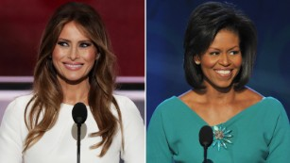
Side-by-side of Melania Trump, Michelle Obama speeches 01:42
McIver said she "asked" to put out a statement because she was concerned about how the controversy was "distracting from Mr. Trump's historic campaign for president and Melania's beautiful message and presentation."
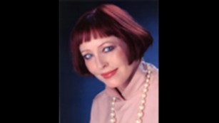
Meredith McIver in a photo posted at her online biography
"I apologize for the confusion and hysteria my mistake has caused. Today, more than ever, I am honored to work for such a great family," McIver said in the statement.
The Trump campaign has refused to acknowledge the incident as plagiarism, instead slamming the media and insisting it was moving on, with no plans to fire any staffers.
But a source close to the Trump campaign conceded that the flap could be a problem for the Republican nominee's campaign. The source specifically focused on McIver's statement, written on Trump Organization letterhead. The source characterized that decision as a big mistake.
That kind of arrangement could raise questions about why someone working for Trump's company was also performing a role for the campaign.
Senior members of Trump's campaign continued to herald Melania Trump's speech.
Cruz walks tightrope between Trump and 2020
"The speech was very effective and communicated those feelings," Trump campaign chairman Paul Manafort said Tuesday on CNN's "New Day." "The controversy you're talking about is not meaningful at all. She's not a candidate for office. She was expressing her personal feelings about her country and her husband and why he's best for the United States."
Who is Meredith McIver?
Manafort on Wednesday agreed Melania Trump's speech used "similar words" to Obama's and insisted, "I'm not lying about anything."
The Republican National Committee also boosted the Trump campaign's defense, with its communications director Sean Spicer slapping down plagiarism charges by pointing to similar words and themes in everything from John Legend songs to "My Little Pony."
John Kasich turned down 'most powerful' VP slot from Trump
Donald Trump, for his part, pressed forward with the strategy of attacking the media as late as an hour before the campaign statement Wednesday.
"The media is spending more time doing a forensic analysis of Melania's speech than the FBI spent on Hillary's emails," Trump said in a tweet.
McIver has served as a ghostwriter for the Trumps in the past, helping Donald Trump write some of his books, including "Trump: Think Like a Billionaire."
The New York Times identified McIver as a former ballet dancer and English major.
Write the answer and highlight the sentence/s where you found the answer.
- Did McIver plagiarize on purpose? _____________

- What were two of the consequences or results of her plagiarism?

EVEN IF IT’S AN ACCIDENT, YOU WILL RECEIVE A 0 ON ANY ASSIGNMENTS OR ESSAYS YOU PLAGIARIZE ON!!!! SO BE CAREFUL! SIGN YOUR NAME HERE TO SHOW YOU UNDERSTAND.

